# Project Design Phase-II

# Technology Stack(Architecture & Stack)

|  |  |
| --- | --- |
| **Date** | 26 October 2022 |
| **Team ID** | PNT2022TMID33933 |
| **Project Name** | Gas Leakage and Monitoring and alerting system |
| **Maximum Marks** | 4 Marks |

**Technical Architecture:**

The Deliverable shall include the architectural diagram as below and the information as per the table1 & table 2

# Example: Order processing during pandemics for offline mode

**Table-1: Components & Technologies:**

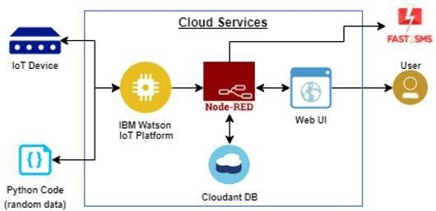

|  |  |  |  |
| --- | --- | --- | --- |
| **S. No** | **Component** | **Description** | **Technology** |
| 1. | User Interface | The user can see our company'sinformation, productionrate.Andtheusercangettoknow about our product and advantages of our product, the disadvantages of the company work without our product. The user can know about every information about our product and also, they can know about our regularservices,discounts,andwarrantyand guaranty for our product and replacement policies. And the user can see the profit flowchartofeachproduct.andtheusercan  see how to track their order. | HTML, CSS, JavaScript |
| 2. | Application Logic-1 | Logic for a process in the application | Java / Python / C# |
| 3. | Application Logic-2 | Logic for a process in the application | IBM Watson STT service |
| 4. | Application Logic-3 | Logic for a process in the application | IBM Watson Assistant |
| 5. | Database | Data Type, Configurations etc. | MySQL, NoSQL, etc. |
| 6. | Cloud Database | Database Service on Cloud | IBM DB2, IBM Cloudant etc. |
| 7. | File Storage | File storage requirements | IBM Block Storage or Other  Storage Service or Local Filesystem |

|  |  |  |  |
| --- | --- | --- | --- |
| 8. | External API-1 | Purpose of External API used in the  application | IBM Weather API, etc. |
| 9. | External API-2 | Purpose of External API used in the  application | Aadhar API, etc. |
| 10. | Machine Learning Model | Purpose of Machine Learning Model | Object Recognition Model, etc. |
| 11. | Infrastructure (Server / Cloud) | Application Deployment on Local System / Cloud Local Server Configuration:  Cloud Server Configuration: | Local, Cloud Foundry, Kubernetes,etc. |

**Table-2: Application Characteristics:**

|  |  |  |  |
| --- | --- | --- | --- |
| **S. No** | **Characteristics** | **Description** | **Technology** |
| 1. | Open-Source Frameworks | “.Net” | “.Net framework (4.7.2) |
| 2. | Security Implementations | The gas monitoring system gives the customer the high-level security and high- level safety. They monitor the gas pipes whether gas leaks happens or not. When the gas leak occurs, it notifies the works andthewholeindustry.Sotheworkerscan turn off the gas pipe. So, they can ignore the gas flow in pipes that stops thespread  of gas in industry. | e.g., SHA-256, Encryptions, IAM Controls, OWASP etc. |

|  |  |  |  |
| --- | --- | --- | --- |
| 3. | Scalable Architecture | The gas detection system can detect every typeofgases.Itcanalsomeasuregasinall concentration levels. It can also measure the gas even if it is less in quantity. This provides the industry a high-level safety and security. And it is also a kindoff  prevention. | Technology used |
| 4. | Availability | Our product will be available every day. And the sensors are able to detect every gas leaks. That leads to low cost of our product. The customer doesn’t need to fix sensors for every single type of gas.  The product has embedded with several sensors.  And it is available in affordable prizes too. | Technology used |
| 5. | Performance | The performance of our product will be great. If it is maintained and serviced properly. The gas leakage monitoring system will work for 24/7. It monitors the gas pipe lines and have 99.9% accuracy of gasleakage.Theperformancewillbegood  if it was maintained and servicedproperly. | Technology used |